1. Mạch nguồn
   1. 12V

gpt

* 1. Hạ áp 5V-4V
     1. [monolithicpower.com/en/documentview/productdocument/index/version/2/document_type/Datasheet/lang/en/sku/MP1584EN-LF-Z/document_id/204/?srsltid=AfmBOopxUN0U2PsvFnhdMVar6m2Vq1vIPK7QeMCZra5hdosKw7zRASsg](https://www.monolithicpower.com/en/documentview/productdocument/index/version/2/document_type/Datasheet/lang/en/sku/MP1584EN-LF-Z/document_id/204/?srsltid=AfmBOopxUN0U2PsvFnhdMVar6m2Vq1vIPK7QeMCZra5hdosKw7zRASsg)

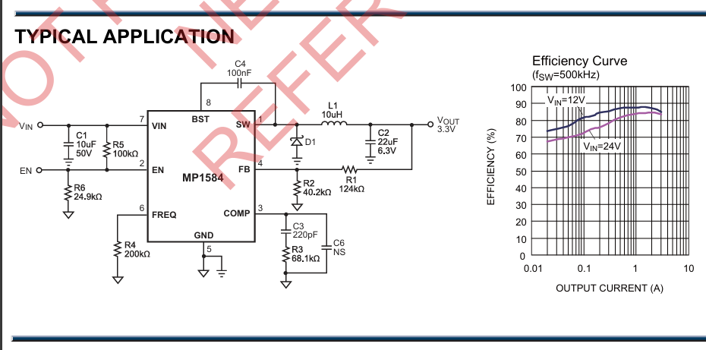

* + 1. [5V 3A Power Supply Designing using MP1584 for All Your Projects](https://www.electroniclinic.com/5v-3a-power-supply-designing-using-mp1584-for-all-your-projects/)

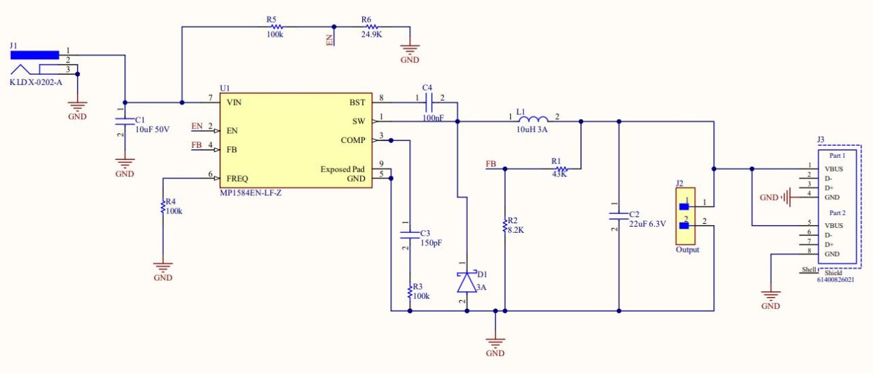

* 1. Hạ áp 3V3

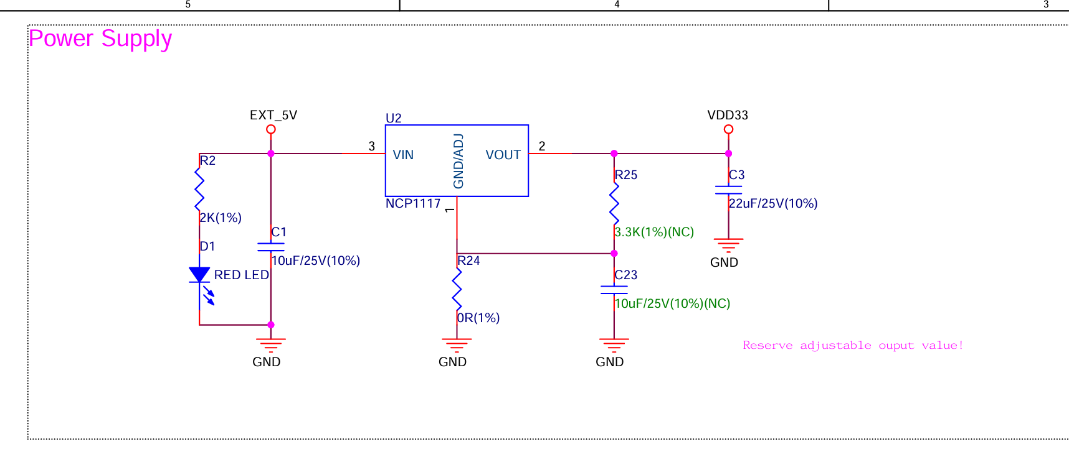

* 1. Sạc & bảo vệ pin
     1. [复件 tp4056_42_English_空页脚.doc](https://dlnmh9ip6v2uc.cloudfront.net/datasheets/Prototyping/TP4056.pdf)

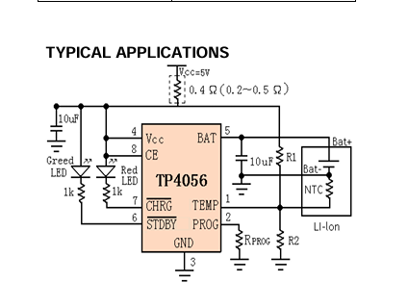

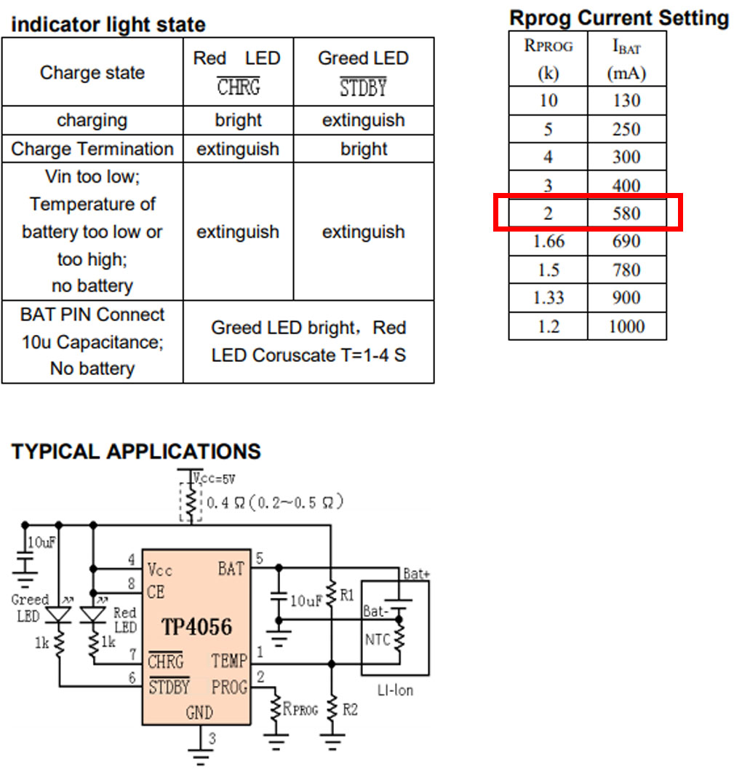

* + 1. [dw01a.pdf](https://hmsemi.com/downfile/dw01a.pdf)

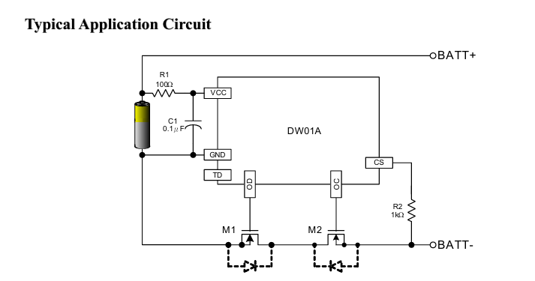

* + 1. [DIY battery charging module schematic BMS](https://electronoobs.com/eng_circuitos_tut49_sch1.php)

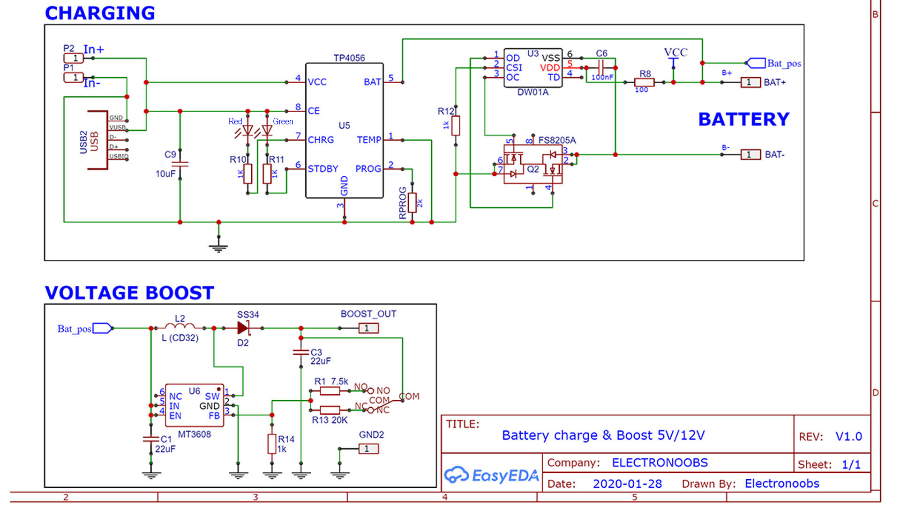

* 1. Tăng áp 5V
     1. [DIY battery charging module schematic BMS](https://electronoobs.com/eng_circuitos_tut49_sch1.php)



1. GPS
   1. [NEO-6M GPS Module: Setup & Introduction | ElectroSchematics](https://www.electroschematics.com/neo-6m-gps-module/)
   2. [Ublox NEO-6M GPS Module - Wiki](http://wiki.sunfounder.cc/index.php?title=Ublox_NEO-6M_GPS_Module)

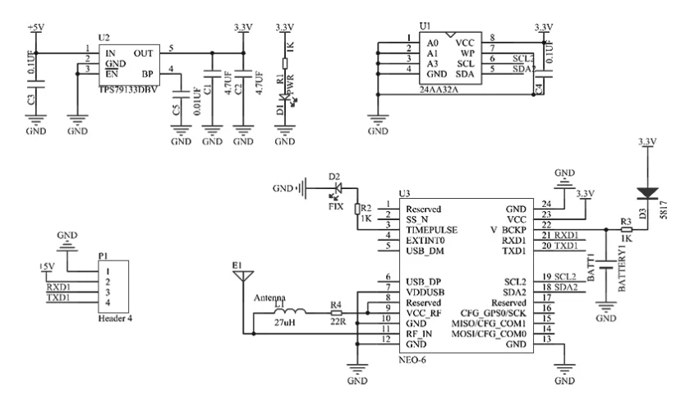

* 1. [Mạch định vị GPS GY-NEO 6M V2 - Nshop](https://nshopvn.com/product/mach-dinh-vi-gps-gy-neo-6m-v2/)

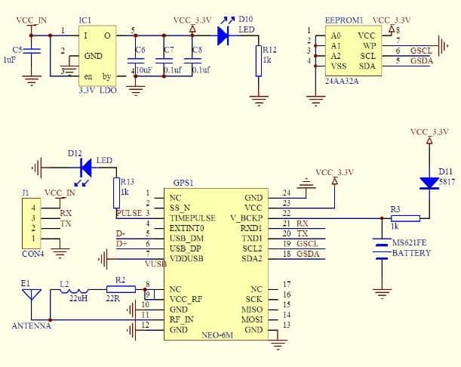

* 1. [How NEO-6M GPS Module Works and How to Interface it with ESP32](https://circuitdigest.com/microcontroller-projects/interfacing-neo6m-gps-module-with-esp32)

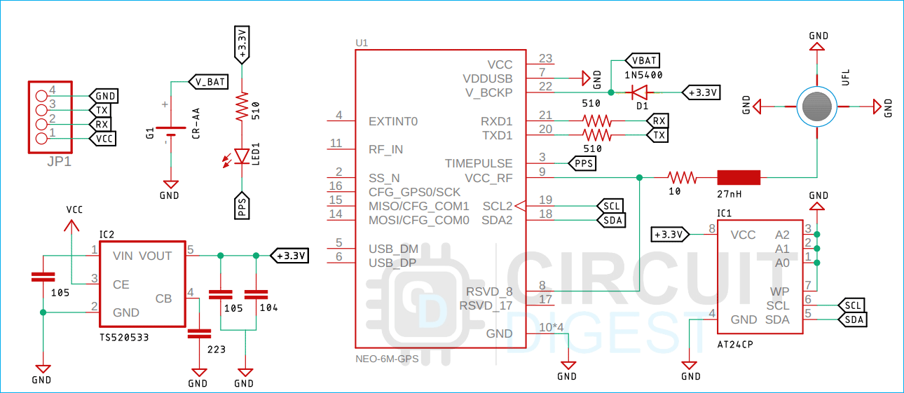

* 1. [NEO-6_DataSheet_(GPS.G6-HW-09005).pdf](https://content.u-blox.com/sites/default/files/products/documents/NEO-6_DataSheet_(GPS.G6-HW-09005).pdf)

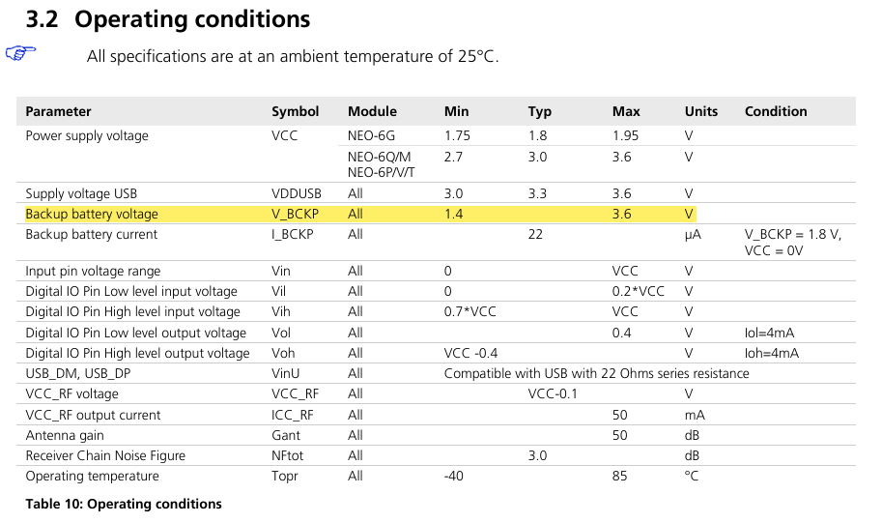

1. MPU6050
   1. [MPU6050 schematic - Sensors - Arduino Forum](https://forum.arduino.cc/t/mpu6050-schematic/662491)

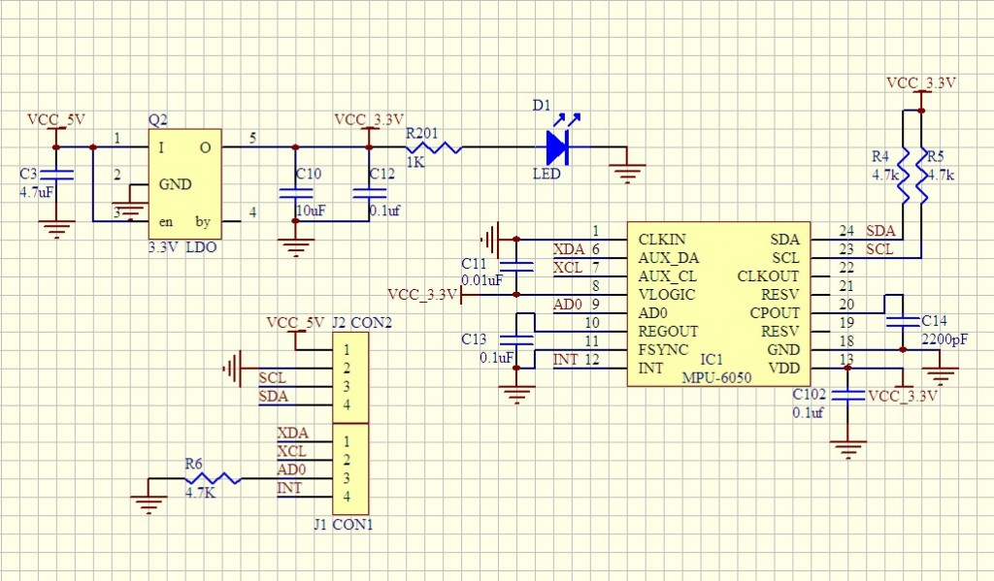

* 1. [i2c - Checking my mpu6050 schematic - Electrical Engineering Stack Exchange](https://electronics.stackexchange.com/questions/438719/checking-my-mpu6050-schematic)

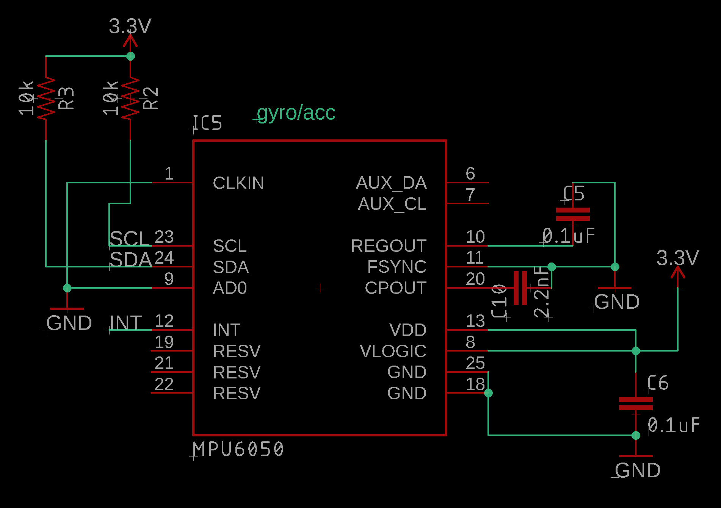

* 1. [Downloads | MPU6050 6-DoF Accelerometer and Gyro | Adafruit Learning System](https://learn.adafruit.com/mpu6050-6-dof-accelerometer-and-gyro/downloads)

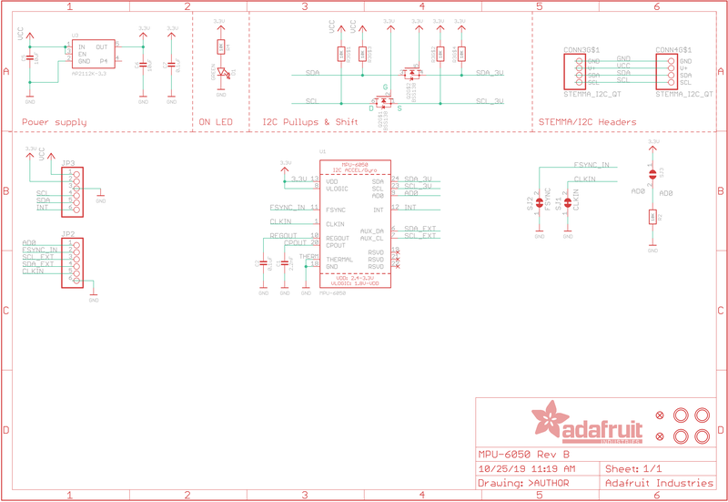

* 1. [Arduino MPU6050 Tutorial - How MPU6050 Module Works and Interfacing it with Arduino](https://circuitdigest.com/microcontroller-projects/interfacing-mpu6050-module-with-arduino)

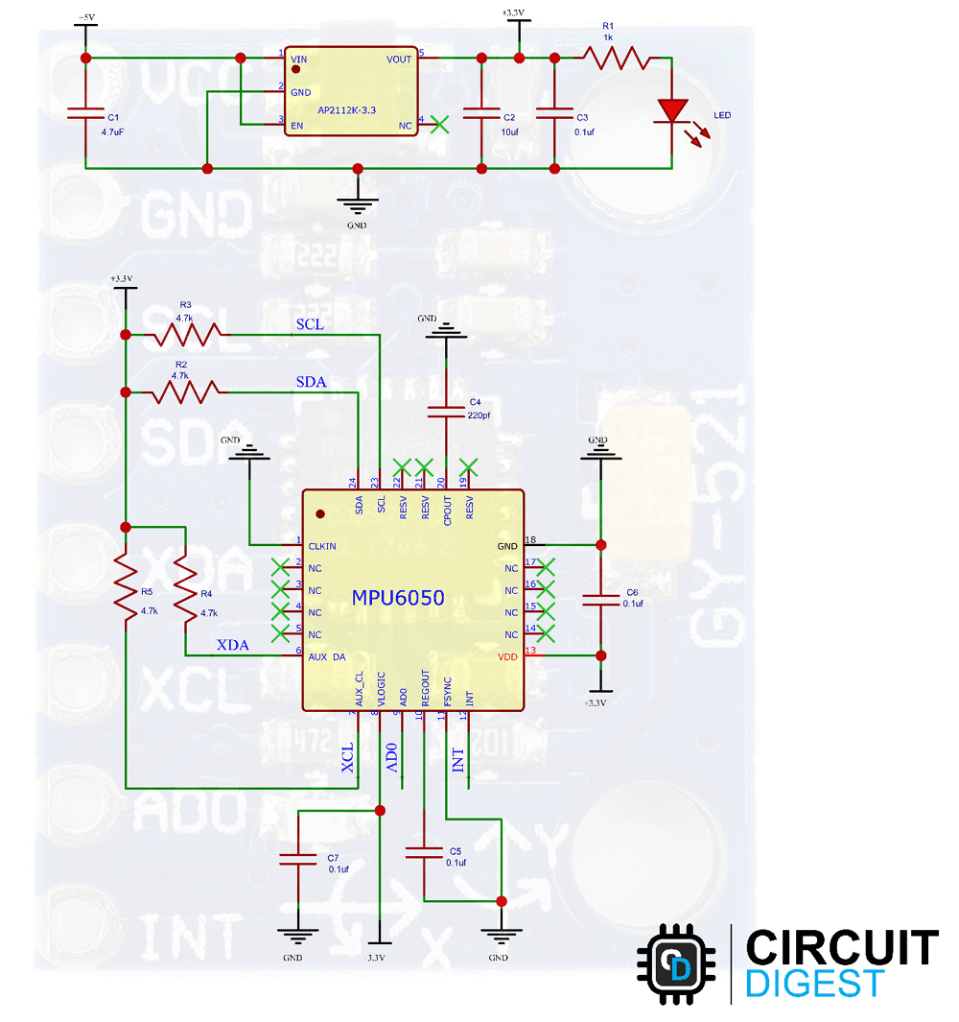

1. Relay 12v
   1. [K6JCA: Schematic, Amazon Relay Module: 1 Channel, Optocoupler Isolation Hi/Low Trigger](https://k6jca.blogspot.com/2022/05/schematic-amazon-relay-module-1-channel.html)

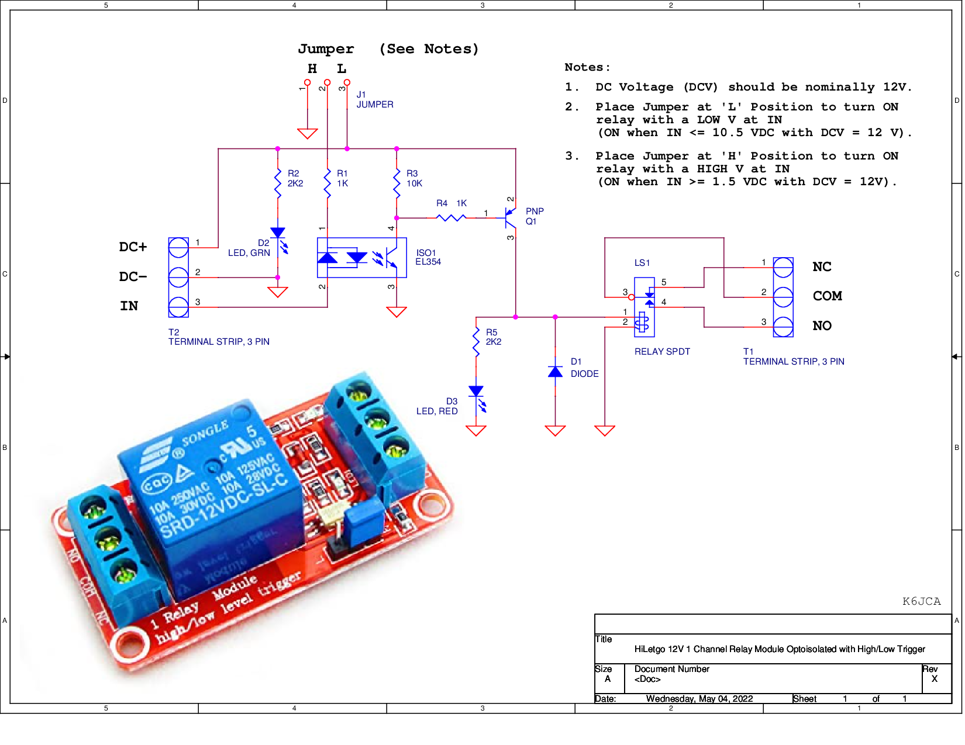

1. ESP32
   1. [esp32_core_board_v2](https://dl.espressif.com/dl/schematics/ESP32-Core-Board-V2_sch.pdf)

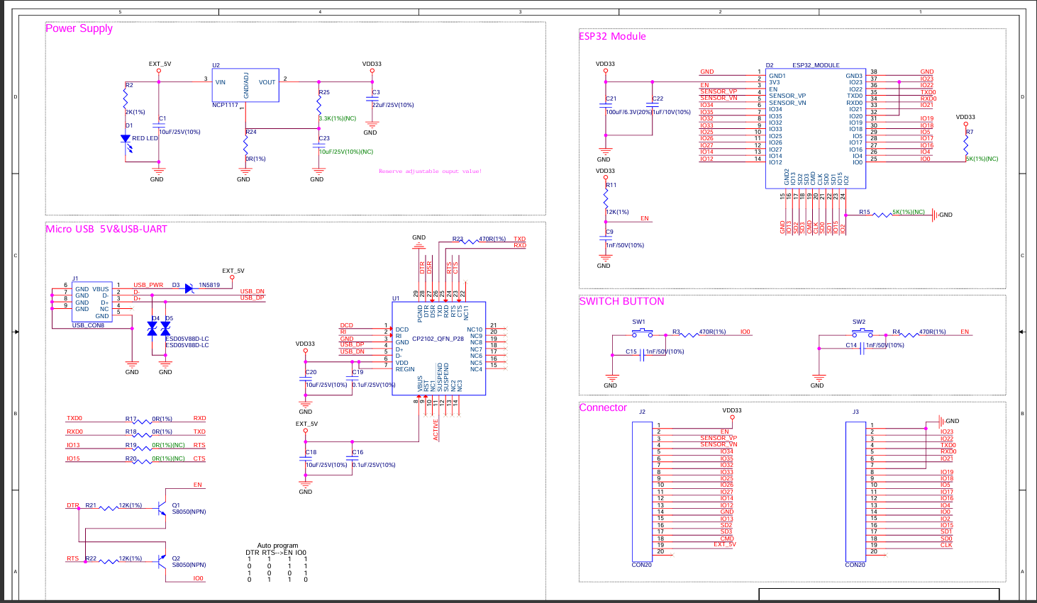

* 1. [ESP32 CP2102 Programmer Schematic - PCB Artists](https://pcbartists.com/design/esp32-cp2102-programmer-schematic/?srsltid=AfmBOooW9fpuQIauFLRaYKulzzM-FJkNAYalK8aFrgzz4HdAuisXJ59j)
  2. [How to replace microUSB with USB-C - PCB Artists](https://pcbartists.com/design/embedded/how-to-replace-microusb-with-usb-c-connector/)

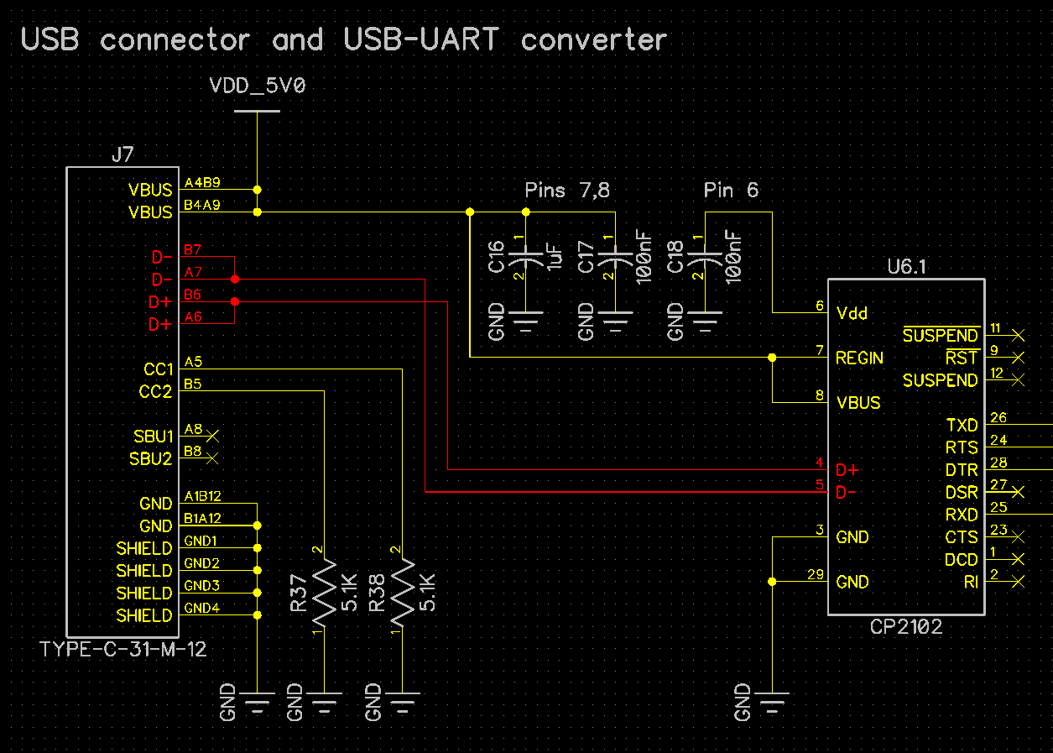

1. MicroSD
   1. [Arduino Micro SD Card Module Tutorial - How SD Card Module Works and How to use it with Arduino](https://circuitdigest.com/microcontroller-projects/interfacing-micro-sd-card-module-with-arduino)

